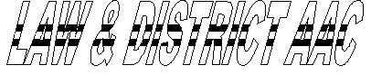

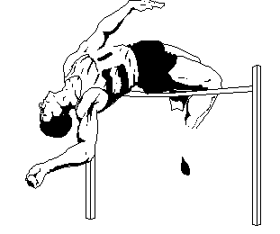

APPLICATION FOR NEW/RENEWAL OF MEMBERSHIP

Surname.................…….................First Name……………………Mr/Mrs/Miss/Ms
Address.........................................................................................………........................
……………………………………………Postcode…………………………………..
Tel Home...........……….…...........Emergency Contact No……………………………
Date of Birth.........................Age……..........Place of Birth……………………………
If member of another Club give name……………………………………………….....
SAL Membership Number ………………………………………………………

Please note that in order to compete in any permitted event you must be a member of the new SAL registration scheme. In order to join please call 0131 476 7321 for an application form. Cost of joining the SAL scheme is £15.00 (Over 17s), £8.00 (Under 17s). Remember the responsibility of joining lies with each individual.

PARENTS/GUARDIANS - PLEASE READ AND SIGN

Certain coaching sessions may require physical contact between coach and child eg throwing sessions where a coach may hold an athlete’s arm to take them through a throwing action or in sprint starts the coach may have to position hands and feet or hold a child in the “set” position or view them from behind. The coach will use as little contact as possible. Unfortunately, drugs are a problem in all sports and children may be asked to participate in doping procedures eg to provide a urine sample under supervision for analysis at an accredited laboratory. Failure to submit to doping control may result in suspension. A list of banned drugs is available on request.

Applicant’s Signature: _____________________________ Date: _________

Signature of Parent/Guardian: _________________________________
(If applicant is under 18)

PERMISSION TO USE PHOTOGRAPHY

From time to time the club will take photographs of our athletes. This may be for a press release or general memorabilia during competitions. We intend to respect the privacy of our athletes and views of parents/guardians. Please delete as appropriate:

I do/do not give permission for my child to be photographed.

Parent/Guardian Signature: _____________________________ Date: ____________

Club Fees 2004/2005 (please circle appropriate fee - see below for details)

Junior Under 11 £7.00 Junior Under 19 £17.00 Over 19 Full £22.00
Junior Under 16 £12.00 Secondary Claim £7.00 Over 19 Ordinary £15.00
PLEASE SEND PAYMENT, MAKING CHEQUE PAYABLE TO
‘LAW & DISTRICT AAC’, TO THE ADDRESS BELOW:

Membership Secretary: | Aileen Thorpe  47 Castlemains Road, Milngavie, Glasgow G62 7QB  0141 956 7145

CATEGORIES OF MEMBERSHIP

Junior Under 11 Member a. Must be affiliated to SAL.
- Shall have a voice but no vote at the AGM
- Must be 9 years of age but under 11 years of age

Junior Under 16 Member a. Must be affiliated to SAL
- Shall have a voice but no vote at the AGM
- Must be 11 years of age but under 16 years of age

Junior Under 19 Member a. Must be affiliated to SAL
- Shall have a voice and a vote at the AGM
- May represent the club in all competitions
- Must be 16 years of age but under 19years of age

Over 19 Full Member a. Must be affiliated to SAL
- Shall have a voice and a vote at the AGM
- May represent the club in all competitions
- Must not be under 19 years of age

Over 19 Ordinary Member a. Shall have a voice and a vote at the AGM
- May only take part in closed (ie Club) competitions
- Must not be under the age of nineteen

Secondary Claim Member a. Must be affiliated to SAL
b. Have a voice but no vote at the AGM

